Co-Chair  Vernon Sykes, Representative  34th House District | 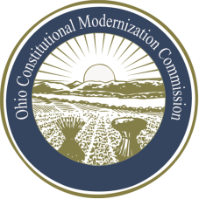 | Co-Chair  William G. Batchelder, Speaker  69th House District
Ohio Constitutional Modernization Commission

Education, Public Institutions, Local Government & Miscellaneous

- Art. VI (Education)

- Art. VII (Public Institutions)

- Art. XV (Miscellaneous)

- School Funding

- Art. X (County and Township Organization)

- Art. XVIII (Municipal Corporations)

- Home Rule

- Adjoining Regionalization and Economic Development

